5.32:
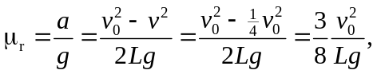
where L is the distance covered before the wheel’s speed is reduced to half its original speed. Low pressure, 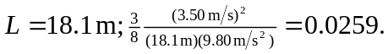 High pressure, 